SIMATS ENGINEERING
ASSESSMENT TOOL 2: Case Study

COURSE NAME: Cloud Computing and COURSE CODE: CSA1511
Big Data Analytics
COURSE OUTCOME COVERED
CO3: Implement cloud-based solutions using cloud storage, web APIs, and platform services for real-world applications. (BL3)
Dave’s Taxonomy: Precision (Level 3) Total Marks: 30
Question Count: 3
Code of Conduct
I Fayza Khatoon.A 192521286 (Name / Reg No) certify that this submission is my original work and that I
have adhered to the guidelines specified for this assessment.
I understand that any violation of academic integrity rules will result in disciplinary action.
Signature of the student: Fayza Khatoon

Assessment Tasks
Case Study
- Case Study 1: Smart Retail Inventory Management System
A retail chain implements a cloud-based inventory system connected to store devices.Clients (POS systems and dashboards) communicate via APIs to centralized cloud services. Cloud storage stores product data, transaction logs, and analytics datasets. The system uses platform services for analytics and demand forecasting. Secure access is maintained through VPNs, firewalls, and API gateways. This solution integrates infrastructure, services, and web applications for efficient operations.
SMART RETAIL INVENTORY MANAGEMENT SYSTEM
1. Introduction
- Overview of Smart Retail Inventory Management System:
The Smart Retail Inventory Management System is a cloud-based application designed to manage and monitor the inventory operations of a retail organization efficiently. In a large retail chain, thousands of products may be distributed across multiple stores and warehouses, making manual inventory management difficult and error-prone. The proposed system connects Point-of-Sale systems, barcode scanners, RFID devices, inventory applications, and management dashboards with centralized cloud services. This enables the organization to maintain a consistent and updated view of product availability across different locations.
2.Need for Cloud-Based Inventory Management:
Traditional inventory systems often store information locally at individual stores, which makes it difficult for the central management team to obtain accurate information about the overall inventory position. A cloud-based solution allows data from different stores to be collected and processed in a centralized environment. Authorized users can access inventory information through web or mobile dashboards without depending on a particular physical location. The cloud architecture also provides scalability, allowing the organization to add new stores, users, products, and transactions without completely redesigning the system.
3.Integration of Store Devices:
The proposed system integrates different store devices such as POS terminals, barcode scanners, RFID readers, smart shelves, and mobile inventory devices. These devices automatically generate information whenever products are sold, received, transferred, or adjusted. The information is transmitted to cloud services through secure APIs. This reduces manual data entry and improves the accuracy and speed of inventory updates.
2. Problem Statement
- Difficulty in Maintaining Accurate Inventory:
Retail organizations manage a large number of products with different SKUs, categories, prices, and stock levels. When inventory is maintained manually, there is a possibility of incorrect quantities being entered into the system. Differences between physical stock and recorded stock can result in financial losses and poor customer service. Therefore, an automated system is required to continuously update inventory based on actual transactions.
- Lack of Real-Time Information:
In a traditional system, information may be updated only at the end of the day or after a manual stock-counting process. This means that store managers may not know the actual quantity of a product currently available. A cloud-based system allows inventory information to be updated immediately after important transactions such as sales, returns, receiving, and stock transfers.
- Stock-Out Problems:
Stock-out occurs when a product is unavailable when customers want to purchase it. Frequent stock-outs can result in lost sales and customer dissatisfaction. The proposed system continuously monitors inventory levels and compares them with predefined reorder levels and safety stock levels. When inventory reaches a critical level, an alert can be generated for the responsible manager.
- Overstocking Problems:
Maintaining excessive quantities of products can increase storage costs and block working capital. Products with short shelf lives can also become damaged or expire. By analyzing historical demand and forecasting future sales, the system can help managers avoid unnecessary overstocking.

3. CASE STUDY DESCRIPTION
3.1 Organization Scenario
The retail organization operates multiple stores located in different geographical locations. Each store handles a large number of products and customer transactions every day. The organization requires a centralized system that can collect information from all stores and provide management with a unified view of inventory and sales.
3.2 Existing Challenges
Challenge | Description
Stock Inaccuracy | Physical stock may differ from recorded stock due to manual errors.
Stock-Out | Products may become unavailable because replenishment is delayed.
Overstock | Excessive inventory increases storage and operational costs.
Data Duplication | Different stores may maintain separate records.
Delayed Reports | Management may not receive updated information immediately.
Manual Work | Employees spend considerable time maintaining inventory records.
Poor Forecasting | Manual prediction may not identify complex sales patterns.
Security Risk | Multiple systems increase the possibility of unauthorized access.

SYSTEM OBJECTIVES
4.1 Primary Objective
To develop a secure and scalable cloud-based inventory management system that connects retail stores, POS systems, cloud services, databases, analytics platforms, and management dashboards.
4.2 Secondary Objectives
- Centralized Data Storage:
Store product, transaction, inventory, supplier, and analytical information in a centralized cloud environment.
- Real-Time Inventory Monitoring:
Provide updated information about product availability across different stores.
- Automated Stock Alerts:
Identify products approaching critical stock levels and notify responsible employees.
- Demand Forecasting:
Analyze historical information to predict future product demand.

- Secure API Communication:
Ensure that communication between POS systems, store devices, and cloud services is properly authenticated and protected.
- Management Reporting:
Provide dashboards and reports that support operational and strategic decision-making.

SYSTEM USERS
User | Main Responsibilities | Access
Store Employee | Sales processing, product scanning, basic stock operations | Limited
Store Manager | Store inventory, alerts, reports and approvals | Medium
Inventory Manager | Organization-wide inventory and replenishment | High
Warehouse Manager | Receiving and dispatching products | High
Business Analyst | Analytics, forecasting and reports | Analytical
Administrator | Users, roles, security and configuration | Full
Senior Management | KPIs and business dashboards | Read/Report

SYSTEM MODULES
5.1 User Management Module
Functions
- User registration
- User login
- Role assignment
- Permission management
- Password management
- Account activation/deactivation
- User activity tracking
Description
The User Management Module controls access to the system. Each employee receives permissions according to their responsibilities. For example, a store employee may process transactions, while an administrator can manage users and system configurations.
5.2 Product Management Module
Product Information
Attribute | Example
Product ID | P1001
SKU | SKU-1001
Product Name | Rice 5 KG
Category | Grocery
Brand | ABC
Unit Price | ₹650
Supplier | Supplier-01
Status | Active
Functions
- Add new products
- Modify product details
- Search products
- Categorize products
- Update prices

6. INVENTORY MANAGEMENT MODULE
- 6.1 Inventory Tracking
- The inventory module maintains the current stock quantity of every product at every store. Stock information changes whenever products are sold, returned, received from suppliers, transferred between stores, or marked as damaged.

6.2 Stock Categories
Category | Meaning | Action
Normal Stock | Sufficient quantity available | Continue monitoring
Low Stock | Quantity approaching reorder level | Prepare order
Critical Stock | Very low quantity | Immediate action
Overstock | Quantity much higher than demand | Reduce future purchases
Out of Stock | Product unavailable | Replenish immediately

6.3 Inventory Calculation
Available Inventory = Opening Stock + Received Stock − Sold Stock − Damaged Stock
- Example:
Parameter | Quantity
Opening Stock | 500
Received | 200
Sold | 150
Damaged | 10
Available Stock | 540

7. ANALYTICS MODULE
7.1 Sales Analytics
The sales analytics module analyzes transaction data collected from different stores. It can identify the products generating the highest sales, products with declining sales, daily sales patterns, store-wise performance, and seasonal changes.
7.2 Inventory Analytics
Inventory analytics provides information about stock movement, inventory turnover, stock availability, excess inventory, and stock-out frequency.
7.3 Product Performance
Products can be classified according to their sales performance.
Product Type | Description
Fast Moving | Products sold in high quantities
Slow Moving | Products with low sales frequency
Seasonal | Products with demand during particular periods
High Value | Products with high monetary value
Critical | Products that require continuous availability

8. BACKUP AND DISASTER RECOVERY
Backup Strategy
- Daily Backup: Important operational data is backed up regularly to reduce the possibility of permanent data loss.
- Incremental Backup: Only information changed since the previous backup can be stored, reducing backup time and storage requirements.
- Database Backup: Critical databases should have dedicated backup procedures.
- Off-Site Backup: Backup copies should be maintained separately from the primary environment.
- Backup Testing: Recovery procedures should be tested periodically to verify that backup data can actually be restored.

9. FUNCTIONAL REQUIREMENTS
Requirement | Description
User Login | Users must authenticate before accessing protected functions.
Product Management | Authorized users can maintain product information.
Inventory Management | Users can view and manage stock information.
POS Integration | Sales transactions can be received from POS systems.
Supplier Management | Supplier information can be maintained.

20. NON-FUNCTIONAL REQUIREMENTS
Requirement | Detailed Description
Performance | The system should process transactions and display inventory information within acceptable response times.
Security | Business and user information must be protected against unauthorized access.
Scalability | The system should support additional stores, products, users, and transactions.
Availability | Services should remain available during normal business operations.
Reliability | Transactions and inventory updates should be processed consistently.
Maintainability | Individual modules should be easy to modify and maintain.
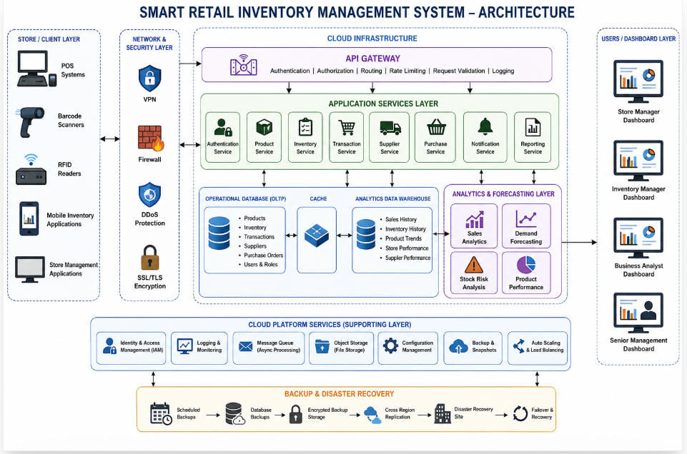

CONCLUSION
The Smart Retail Inventory Management System provides a centralized and intelligent approach to managing inventory across multiple retail stores. By connecting POS systems, barcode scanners, RFID devices, cloud services, databases, analytics platforms, and dashboards, the system provides a complete flow of information from product sales to inventory management and management decision-making.
The cloud-based architecture improves accessibility, scalability, and centralized control. API-based integration enables different store systems and cloud services to communicate efficiently. The inventory module provides updated stock information, while automated alerts help managers identify products that require replenishment.
Case Study 2: Cloud-Based Document Collaboration System
An enterprise deploys a document collaboration tool similar to Google Docs. Users access the platform via browsers, enabling real-time editing and sharing. Documents are stored in distributed cloud storage with version control mechanisms. Web APIs enable synchronization across multiple clients and devices. Network infrastructure ensures low latency and high availability globally. Security includes encryption, identity management, and access permissions for collaboration.
1. Introduction
1.1 Overview
A Cloud-Based Document Collaboration System is a platform that allows multiple users to create, edit, store, share, and manage documents through the internet. The system works similar to applications such as Google Docs, where users can access documents using web browsers without installing heavy software on their computers.
1.2 Purpose of the System
The main purpose of the system is to provide a centralized environment where users can work together on documents from different locations. Multiple users can edit the same document simultaneously, while the system manages synchronization, document versions, permissions, and secure storage.
1.3 Cloud-Based Approach
Instead of storing documents only on individual computers, the system stores them in distributed cloud storage. This allows users to access their documents from laptops, desktops, tablets, and mobile devices. Cloud infrastructure also provides scalability, backup, high availability, and global accessibility.
2. Problem Statement
Traditional document management systems create several problems when multiple people need to work together.
Major Problems
- Multiple Copies of Documents:
Users may create different copies of the same document and send them through email or messaging applications. This can result in confusion about which copy contains the latest changes.
- Difficulty in Real-Time Collaboration:
Traditional desktop applications may not allow multiple users to edit the same document simultaneously. Users may have to wait for another person to finish editing.
3. Objectives
3.1 Primary Objective
To develop a secure, scalable, and highly available cloud-based document collaboration platform that allows multiple users to create, edit, share, synchronize, and manage documents in real time.
3.2 Secondary Objectives
- Provide browser-based document access.
- Support simultaneous document editing.
- Maintain document versions.
- Synchronize changes across multiple devices.
- Provide secure cloud storage.
- Implement user authentication and identity management.
- Provide document-level access permissions.
- Support secure sharing between users.

4. System Users
User | Responsibilities | Access Level
Document Owner | Creates and manages documents | Full
Editor | Modifies document content | Edit
Commenter | Adds comments and suggestions | Comment
Viewer | Reads documents | Read Only
Administrator | Manages users and system configuration | Administrative
Organization Manager | Manages organizational documents and users | High

5. Major System Modules
5.1 User Authentication Module
The authentication module verifies the identity of users before they access the platform. Users can log in using their credentials, and additional security mechanisms such as multi-factor authentication can be implemented.
Functions
- User registration
- Login
- Logout
- Password management
- Multi-factor authentication
6. Document Management Module
The document management module handles the complete document lifecycle.
Functions
- Create documents
- Open documents
- Edit documents
- Rename documents
- Delete documents
- Move documents
6. Document Management Module
The document management module handles the complete document lifecycle.
Functions
- Create documents
- Open documents
- Edit documents
- Rename documents
- Delete documents
- Move documents

7. Real-Time Collaboration

7.1 Simultaneous Editing
The most important feature of the system is real-time collaboration. Multiple users can open the same document and make changes at the same time.
For example:
User A → Edits Paragraph 1
↓
Collaboration Server
↓
User B → Receives Update
↓
User B → Edits Paragraph 3
↓
Collaboration Server
↓
User A → Receives Update
Change Synchronization
Whenever a user makes a change, the client sends the change to the server through a web API or real-time communication channel. The server processes the modification and distributes the updated information to other connected users.
7.3 Conflict Management
When multiple users modify the same part of a document simultaneously, the system needs mechanisms to prevent one user's changes from incorrectly overwriting another user's changes.
Technologies such as Operational Transformation (OT) or Conflict-Free Replicated Data Types (CRDTs) can be used to manage concurrent editing.

8.Web API Layer
Web APIs act as communication interfaces between browsers, mobile applications, and backend cloud services.

Major API Functions
API | Purpose
Authentication API | Login and identity verification
Document API | Create and manage documents
Editing API | Submit document changes
Sharing API | Manage document sharing
Version API | Retrieve previous versions
Comment API | Add and manage comments
Search API | Search documents
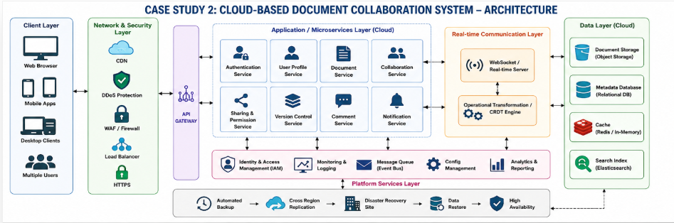
Version Control
Version control is an important feature of the document collaboration platform.
Whenever significant changes are made, the system can maintain a new document version.
Version Example

Version | User | Change | Time
V1 | User A | Created document | 10:00 AM
V2 | User A | Added introduction | 10:15 AM
V3 | User B | Added methodology | 10:30 AM
Architecture Layer Explanation
13.1 Client Layer
The client layer consists of the interfaces through which users access the collaboration platform.
Components
- Web browsers
- Desktop applications
- Mobile applications
Network Layer
The network layer provides communication between users and cloud infrastructure.
Components
- Internet
- HTTPS
- Content Delivery Network
- Load Balancer
API Gateway
The API Gateway manages communication between clients and backend services.
Responsibilities
- Request authentication
- API routing
- Request validation

Encryption
- Encryption in Transit
- Communication between users and cloud services should use secure protocols such as HTTPS/TLS.
- Encryption at Rest
- Documents and metadata stored in cloud infrastructure should be encrypted to protect them from unauthorized access.
- Key Management
- Encryption keys should be managed securely through centralized key-management mechanisms. Access to encryption keys should be restricted to authorized services.
High Availability
The system should continue operating even if individual infrastructure components fail.
Techniques
- Multiple application servers
- Load balancing
- Database replication

Testing
- 27.1 Functional Testing
- Tests whether document creation, editing, sharing, commenting, searching, and version management work correctly.
- 27.2 Collaboration Testing
- Tests whether multiple users can edit the same document simultaneously without losing changes.
- 27.3 Synchronization Testing
- Tests whether changes made on one device are correctly reflected on other connected devices.
Advantages
Major Advantages
- Real-Time Collaboration: Multiple users can work on the same document simultaneously.
- Centralized Storage: Documents are stored in a centralized cloud environment rather than individual computers.
- Global Accessibility: Users can access documents from different geographical locations.
- Version Management: Previous document versions can be maintained and restored.
- Reduced Duplication: Users do not need to maintain multiple copies of the same document.

Future Enhancements
- Artificial Intelligence
- AI can provide automatic document summarization, grammar correction, content recommendations, and intelligent document search.
- AI-Based Search
- Users can search documents using natural language rather than exact keywords.
- Voice Collaboration
- Future systems can allow users to dictate document content using speech recognition.

Conclusion
- The Cloud-Based Document Collaboration System provides an efficient platform for creating, editing, sharing, and managing documents through cloud infrastructure. The system eliminates many limitations associated with traditional document storage and file-sharing methods by providing centralized storage, real-time collaboration, synchronization, and version control.
- The architecture combines web browsers, APIs, cloud application services, distributed storage, databases, real-time collaboration services, security mechanisms, and global network infrastructure. Multiple users can access the same document from different devices while changes are synchronized across connected clients

3. Case Study 3: Online Food Ordering Platform
A startup builds a cloud-based food ordering system accessible via web browsers and mobile clients. Frontend clients interact with backend services through RESTful Web APIs hosted on a cloud platform. Cloud storage is used to store menu images, invoices, and customer data securely. The infrastructure uses virtual machines and managed Kubernetes for scalability and reliability. Security is enforced through authentication tokens, HTTPS, and role-based access control. The system demonstrates integration of clients, APIs, storage, and platform services in real time.
1. INTRODUCTION
1.1 Overview
The Online Food Ordering Platform is a cloud-based application that allows customers to browse restaurants, view food menus, select items, place orders, make payments, and track their orders using web browsers and mobile applications. The platform connects customers, restaurants, delivery personnel, payment services, and administrators through cloud-hosted backend services.
1.2 Purpose of the System
The main purpose of the system is to provide a convenient and reliable platform for ordering food online. Customers do not need to visit restaurants physically or make phone calls to place orders. They can select food items, customize their orders, provide delivery details, make payments, and monitor order status through the application.
2. PROBLEM STATEMENT
Traditional food ordering methods can create several difficulties for both customers and restaurants.
Major Problems
- Manual Ordering: Customers may need to call restaurants to place orders, which can result in communication errors.
- Limited Accessibility: Traditional ordering may not provide customers with a convenient way to view complete menus and prices.
- Order Management Difficulties: Restaurants may find it difficult to manage a large number of orders during peak hours.
- Payment Issues: Manual payment methods can increase processing time and create difficulties in tracking transactions.
3. OBJECTIVES OF THE SYSTEM
3.1 Primary Objective
To develop a secure, scalable, and reliable cloud-based online food ordering platform that allows customers to browse menus, place orders, make payments, and track deliveries through web and mobile applications.
3.2 Secondary Objectives
- Provide web-based and mobile-based access.
- Allow customers to browse restaurants and menus.
- Provide food search and filtering.
- Allow customers to add items to a cart.
- Support online order placement.

4. SYSTEM USERS
User | Responsibilities | Access Level
Customer | Browse menu, order food, make payment, track order | Customer
Restaurant Manager | Manage menu, prices, orders and restaurant information | Restaurant
Restaurant Staff | Prepare and update food orders | Limited Restaurant
Delivery Partner | Accept delivery and update delivery status | Delivery
5. MAJOR SYSTEM MODULES
5.1 Customer Management Module
The customer management module maintains customer information and provides facilities for registration, login, profile management, address management, and order history.
Functions
- Customer registration
- Customer login
- Profile management
- Address management
- Password management
- Order history
6. RESTAURANT MANAGEMENT MODULE
Restaurant owners or managers can manage their restaurant information through this module.
Functions
- Restaurant registration
- Restaurant profile management
- Restaurant operating hours
- Menu management
- Food category management
- Food price management

7. FOOD MENU MANAGEMENT
- The menu management module allows restaurants to add, update, and remove food items.

Food Item Information
Field | Example
Food ID | FOOD1001
Food Name | Chicken Biryani
Category | Main Course
Price | ₹250
8. FOOD SEARCH AND DISCOVERY
Customers should be able to search and discover restaurants and food items easily.
Search Options
- Restaurant name
- Food name
- Food category
- Cuisine type
- Price range
- Customer rating
- Location
MANAGED KUBERNETES
Managed Kubernetes is used to deploy and manage containerized backend services.
Kubernetes Responsibilities
- Container orchestration
- Automatic scaling
- Service discovery
- Load distribution
- Container health monitoring
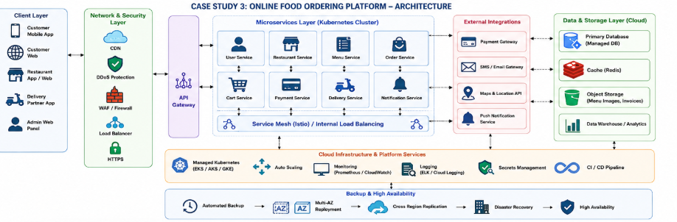
9. VIRTUAL MACHINES
Virtual machines provide computing environments for application workloads, supporting infrastructure services, monitoring, administration, and other required workloads.
Advantages
- Flexible resource allocation
- Isolation between workloads
- Easier infrastructure management
- Support for legacy applications
10. CLOUD STORAGE
Cloud storage is used to securely store large files and objects.
Stored Information
- Restaurant images
- Food images
- Menu images
- Customer invoices
- Order documents
11. PAYMENT PROCESSING
The payment service allows customers to pay for their orders through supported payment methods.
Payment Methods
- Credit card
- Debit card
- UPI
- Digital wallets

CONCLUSION
- The Online Food Ordering Platform provides a complete cloud-based solution for connecting customers, restaurants, delivery partners, payment services, and administrators through a single digital platform. Customers can browse restaurants, select food items, place orders, make payments, and track deliveries using web browsers or mobile applications.
- The platform uses RESTful Web APIs to connect frontend clients with backend cloud services. Cloud storage securely maintains menu images, invoices, and other files, while databases maintain structured information such as customers, restaurants, menus, orders, payments, and delivery details.

